I created a Python script to visualize the weather of 500+ cities across the world of varying distance from the equator. Using [Python library- Citypy](https://pypi.python.org/pypi/citipy), and the [OpenWeatherMap API](https://openweathermap.org/api).

A full description of the project and the data analysis with summary can be found on my [Web Visualization repo.](https://tomberton.github.io/WebVisualization/)

Using Matplotlib a series of scatter plots to showcase the following relationships:

* Temperature (F) vs. Latitude

The analysis of the latitude versus the maximum temperature occured on November 11, 2017. During this time of year the Northern hemisphere (latitude > 0°) is cooler than the Southern hemisphere (latitude < 0°). It is no surprise that the cities with the greatest maximum temperature are those closest to the equator. Interestingly, the majority of the cities generated from using the CityPy module are located in the Northern hemisphere.

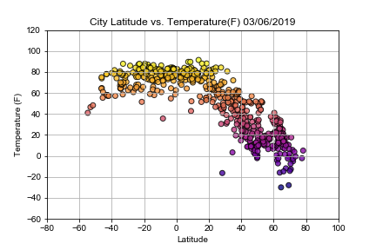

* Humidity (%) vs. Latitude

he analysis of the latitude versus the humidity occured on November 11, 2017. Humidity is the measure of water vapor in the air. When the humidity is 100% then the air can't hold any more water vapor. When surface temperature of the land masses and sea warms, it leads to more evaporation, and consequently an increase in humidity. An increase in humidity can lead to additional warming of the land masses and sea.

Analysis of the data shows that latitude does not impact the percent humidity. However, the majority of the cities generated from the analysis had humidity levels greater than 60%. Does this indicate more water evaporation due to increased global warming? Or, is it a result of generating random latitudes and longitudes? Since, the majority of the Earth (71%) is covered by water, where the majority of our randomly generated latitudes and longitudes over a body of water? If so, then this makes the nearest city to those latitudes and longitudes along coastlines and other bodies of water. Also, humidity is dependent upon temperature and cloudiness. Further analysis of the how many cities had maximum temperatures above 60° F may shed light on why the majority of cities had high levels of humidity. Click on the the Latitude vs. Cloudiness image to see how cloudy it is with a change in latitude.

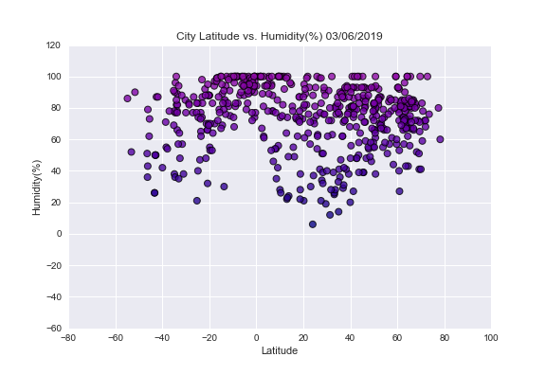

* Cloudiness (%) vs. Latitude

The analysis of the latitude versus cloudiness occured on November 11, 2017. The data show that there is no relationship between latitude and cloudiness. However, further anlaysis of the data can help determine a relationship between the cities with very low amounts of clouds and humidity and / or temperature.

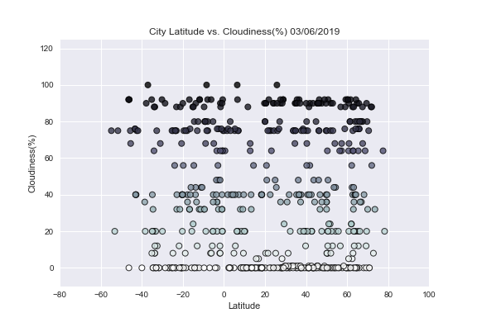

* Wind Speed (mph) vs. Latitude

The analysis of the latitude versus wind speed occured on November 11, 2017. On this day, the data show that the majority of the randomly generated cities had wind speeds <15-20 mph. Contributing factors to wind speed include, hurricanes and monsoons. Hurricane season, which occurs June 1 through November 30, was coming to an end on the day of this analysis. The Northern monsoon season, which occurs late June through September, was over, but the Southern monsoon season, which is October through April, was beginning.

